Welcome to the 6th Grade ELA
This summer packet will help you get ready for the upcoming school year and prepare you for 6th-grade English Language Arts.

- Objective: I can and will complete Weekly Journal Entries
- Objective: I can and will do my best to write full sentences.
- Objective: I can and will re-read my answers before submitting the packet.
- Objective: I can read for at least 20-min each day.
- Objective: I can and will do my best in 6th-grade English Language Arts

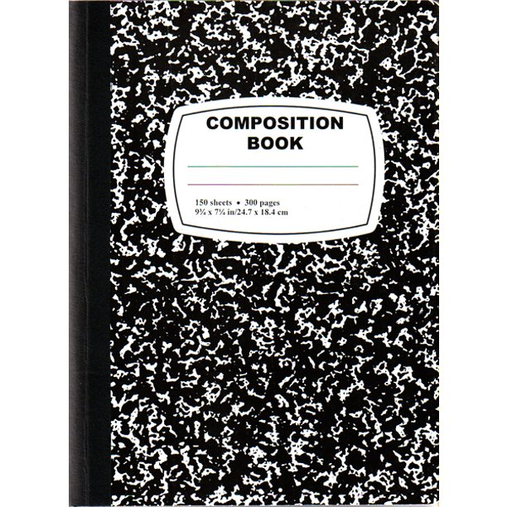
Weekly Journal Entries

Your day-to-day life is history in the making! You have endured a challenging year and a half in the midst of a global pandemic, all while keeping up with your academics, family and social situations, and social-emotional well-being. To gear up for the 2022-23 school year, it is important to keep checking in with yourself and to keep writing.

- Get a hardcover notebook (see picture)
- Feel free to decorate your notebook & pages however you would like!
- Write a minimum of ONE journal entry (1+ page[s] per week. Describe your daily life, what you are doing this summer, what you are looking forward to for the next school year as you enter middle school, etc.
- *NOTE* Ideally, you would write in your journal more often (even once a day!)

- Here are some ideas for what you could write about and you may include pictures to capture special moments or experiences. Feel free to get creative!:
- How are you feeling?
- How did you spend your time today/this week?
- What was the best/most memorable event that happened today/this week?
- Who did you spend time with today/this week?
- Where are some places you went today/this week?
- What was on your mind this week/today (what did you spend a lot of time thinking about)?
- Challenge yourself to…
-Watch a new show (or a new sport… )
-Listen to a new genre of music
-Try a new game/sport
-Write a poem
-Interview a relative and ask them about their life
-Research a historical figure, another place (state, country, environment) on Earth, or an animal that you think is really cool!
… then, write about it! What was that experience like?
- What thoughts/questions/concerns do you have for the next school year?

Remember, your teachers will be reading these! We may also continue our journal writing routine at school in the fall.

Summer Reading Challenge Assignments for Summer 2022:
- Challenge yourself to read for approx. 20 minutes every day!
- Keep the subtitles/captions ON when you watch television. This may seem annoying at first, but studies have shown that this improves your fluency.
- Finally, any reading you do this summer is GREAT! Here is a list of some other grade-level books that might be of interest:
Website:https://shop.scholastic.com/parent-ecommerce/grades/6th-grade.html

- 